**Thibaut FONTAINE**

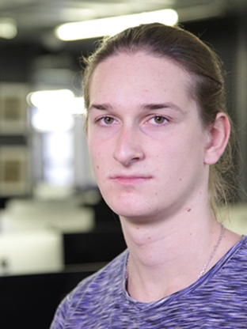

I   
171 boulevard Victor Hugo, apt. 140

Les Estudines Victor Hugo

92110 CLICHY, FRANCE  
Mob : +33 6 52 50 26 87

[tfontain@student.42.fr](mailto:tfontain@student.42.fr)

20 years old, French

**Internship**

Student at 42 Paris School

Experience, participation to IT events

i

**05/2017 Winner of the SexTechLab Hackathon**

* 1st place in a Hackathon about innovation in sexuality. Me and my team have created a chatbot, using machine learning, which explains and speak about sexuality to teenagers.

**12/2016 Workshop, and Hackathon by Cisco**

* On the theme of smart cities. Using data of the city of Paris, we created a chatbot about tourism.

**Since 12/2016 Several conferences and meet-ups (IBM, iHealth, Microsoft, Airbus, etc.)**

**07/2015 Summer job in a postal service sorting center (La Poste).**

Education

i

**Since 11/2016 42 Paris School – Algorithmic section**

* Fighting algorithm, combining assembly and virtual machine (Core Wars)
* Algorithm dealing about graph theory, shortest path, etc.
* Other various projects : sorting, display, reading, optimal solution, etc.

**09/2015 - 06/2016 University of Rouen**

* Mathematics and computer sciences
* Digital Electronics

**06/2015 Blaise Pascal High school - Rouen**

* French Scientific baccalauréat
* Specialized in Engineering sciences, physics and chemistry

Skills

**Computer science**

Good knowledge of C, Python, Git, and Unix.

Basics in C++, Php/Mysql, Javascript, programming in embedded systems, electronics.

**Spoken languages**

Full professional proficiency in English, Native in French

Hobbies and interests

Playing guitar, Computer sciences, Movies, Entrepreneurship